Computation Physics
Phys 6312

Home work (3)

Done By:
Mohammed K. El-habbash
120080242

Supervisor:
Dr. Maher O. El-Ghossain
Associate Professor
For a projectile motion consider a ball of mass m=0.200Kg , and area A=3.5*10³ m²
Moving with initial velocity Vi=30.0 i + 24.0 j m/s and initial position ri=0.0 i +0.0 j m/s ,Compare Euler(simple) method with other methods to solve the basic equation of motion:

dv/dt = (1/m) Fa(v) – g j
dr/dt = v.
where Fa(v) = (1/2) (ρ Cd) A⏐v⏐² v : is the force due to air resistance , Cd : is the drag coefficient , ρ : is the air resistance = 1.2 Kg/m³ , A: is cross section area.

Find : (a) the range
(b) maximum height .
(c) time of flight
(d) plot height vs range for each method
For :
(One): Cd=0.0
(Two): Cd=0.25

Solution:

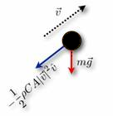

% a projectile motion Problem
% A ball of mass (m)= 0.200Kg , with cross section area (A) =3.5*10³ m²
% Moving with initial velocity (Vx)=30.0 m/s ,and (Vy)= 24.0 m/s
% and initial position (X)= 0.0 meter and, (Vy)= 0.0 meter
% with air resistance (p)= 1.2 Kg/m³
% and drag coefficient (Cd)= 0 or 0.25
% Earth Gravity (g)= 9.8 m/s^2
% Solving this problem using Simple (Euler)method

clear all;
clc;
% Initialization of Variabels
g=9.8;
p=1.2;
m=0.2;
h=0.01;
N=30/h;
A=3.5e-3;
tfinal=0;
maximum_hight=0;
Range=0;

Cd0=0;
Vx0(1)=30;
Vy0(1)=24;
ax0(1)=0;
ay0(1)=0;
X0(1)=0;
Y0(1)=0;

for t=1:1:N
ax0(t)=-0.5*p*Cd0*A*sqrt((Vx0(t)^2+Vy0(t)^2))*Vx0(t)/m;
ay0(t)=-0.5*p*Cd0*A*sqrt((Vx0(t)^2+Vy0(t)^2))*Vy0(t)/m-g;
Vx0(t+1)=h*ax0(t)+Vx0(t);
Vy0(t+1)=h*ay0(t)+Vy0(t);
X0(t+1)=X0(t)+Vx0(t)*h+0.5*ax0(t)*h^2;
Y0(t+1)=Y0(t)+Vy0(t)*h+0.5*ay0(t)*h^2;
if Y0(t+1)>0
tfinal0=t+1;
Range0=X0(t+1);
end
if Y0(t+1)>Y0(t)
maximum_hight0=Y0(t+1);
end
end
%Theoritical Result for Cd=0
flight_time_theoritic=2*Vy0(1)/(0.5*p*Cd0*A*sqrt((Vx0(1)^2+Vy0(1)^2))*Vy0(1)/m+g)
maximum_hight_theoritic=Vy0(1)^2/(2*(0.5*p*Cd0*A*sqrt((Vx0(1)^2+Vy0(1)^2))*Vy0(1)/m+g))
Range_theoritic=Vx0(1)*flight_time_theoritic+0.5*ax0(tfinal0)*flight_time_theoritic^2

%Calculated Result for Cd=0
flight_time_computizes=tfinal0*h
maximum_hight_computized=maximum_hight0*1
Range_computized=Range0

Cd=0.25
Vx(1)=30;
Vy(1)=24;
ax(1)=0;
ay(1)=0;
X(1)=0;
Y(1)=0;

for t=1:1:N
ax(t)=-0.5*p*Cd*A*sqrt((Vx(t)^2+Vy(t)^2))*Vx(t)/m;
ay(t)=-0.5*p*Cd*A*sqrt((Vx(t)^2+Vy(t)^2))*Vy(t)/m-g;
Vx(t+1)=h*ax(t)+Vx(t);
Vy(t+1)=h*ay(t)+Vy(t);
X(t+1)=X(t)+Vx(t)*h+0.5*ax(t)*h^2;
Y(t+1)=Y(t)+Vy(t)*h+0.5*ay(t)*h^2;

if Y(t+1)>0
tfinal=t+1;
Range=X(t+1);
end
if Y(t+1)>Y(t)
maximum_hight=Y(t+1);
end
end

%Theoritical Result for Cd=0.25
flight_time_theoritic=2*Vy(1)/(0.5*p*Cd*A*sqrt((Vx(1)^2+Vy(1)^2))*Vy(1)/m+g)
maximum_hight_theoritic=Vy(1)^2/(2*(0.5*p*Cd*A*sqrt((Vx(1)^2+Vy(1)^2))*Vy(1)/m+g))
Range_theoritic=Vx(1)*flight_time_theoritic+0.5*ax(tfinal)*flight_time_theoritic^2

%Calculated Result for Cd=0.25
flight_time_computized=tfinal*h
maximum_hight_computized=maximum_hight*1
Range_computized=Range

plot(X0(1:tfinal0),Y0(1:tfinal0),'black'), hold on;
plot(X(1:tfinal),Y(1:tfinal),'black--'), hold on;
grid;
legend('Cd =0', 'Cd =0.25');
xlabel('X (meter)')
ylabel('Y (meter)')

Result of Solve by Simple (Euler)method:

 | Cd=0 |  | Cd=0.25
 | theoritical | computized | theoritical | computized
flight_time | 4.8980 | 4.9000 | 3.9279 | 4.5800
maximum_hight | 29.3878 | 29.3878 | 23.5672 | 25.7132
Range | 146.9388 | 146.7000 | 104.8190 | 115.3370

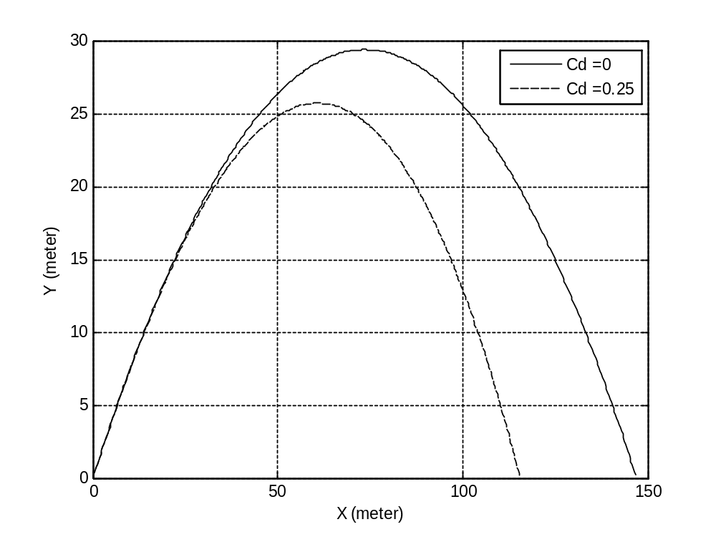

% a projectile motion Problem
% A ball of mass (m)= 0.200Kg , with cross section area (A) =3.5*10³ m²
% Moving with initial velocity (Vx)=30.0 m/s ,and (Vy)= 24.0 m/s
% and initial position (X)= 0.0 meter and, (Vy)= 0.0 meter
% with air resistance (p)= 1.2 Kg/m³
% and drag coefficient (Cd)= 0 or 0.25
% Earth Gravity (g)= 9.8 m/s^2
% Solving this problem using Taylor method

clear all;
clc;
% Initialization of Variabels
g=9.8;
p=1.2;
m=0.2;
h=0.01;
N=50/h;
A=3.5e-3;

Cd0=1e-6;
Vx0(1)=30;
Vy0(1)=24;

ax0(1)=-0.5*p*Cd0*A*sqrt((Vx0(1)^2+Vy0(1)^2))*Vx0(1)/m;
ay0(1)=-0.5*p*Cd0*A*sqrt((Vx0(1)^2+Vy0(1)^2))*Vy0(1)/m-g;

dt_ax0(1)=ax0(1);
dv_ax0(1)=ay0(1);
dt_ay0(1)=ax0(1)/Vx0(1);
dv_ay0(1)=ay0(1)/Vy0(1);

Vx0(2)=Vx0(1)+h*ax0(1)+0.5*h^2*(dt_ax0(1)+ax0(1)*dv_ax0(1));
Vy0(2)=Vy0(1)+h*ay0(1)+0.5*h^2*(dt_ay0(1)+ay0(1)*dv_ay0(1));

ax0(2)=-0.5*p*Cd0*A*sqrt((Vx0(2)^2+Vy0(2)^2))*Vx0(2)/m;
ay0(2)=-0.5*p*Cd0*A*sqrt((Vx0(2)^2+Vy0(2)^2))*Vy0(2)/m-g;

dt_ax0(2)=(ax0(2)-ax0(1))/h;
dv_ax0(2)=(ax0(2)-ax0(1))/(Vx0(2)-Vx0(1));
dt_ay0(2)=(ay0(2)-ay0(1))/h;
dv_ay0(2)=(ay0(2)-ay0(1))/(Vy0(2)-Vy0(1));

X0(1)=0;
Y0(1)=0;
X0(2)=X0(1)+Vx0(1)*h+0.5*ax0(1)*h^2;
Y0(2)=Y0(1)+Vy0(1)*h+0.5*ay0(1)*h^2;
tfinal0=0;
maximum_hight0=0;
Range0=0;

for t=2:1:N
ax0(t)=-0.5*p*Cd0*A*sqrt((Vx0(t)^2+Vy0(t)^2))*Vx0(t)/m;
ay0(t)=-0.5*p*Cd0*A*sqrt((Vx0(t)^2+Vy0(t)^2))*Vy0(t)/m-g;
dt_ax0(t)=(ax0(t)-ax0(t-1))/h;
dv_ax0(t)=(ax0(t)-ax0(t-1))/(Vx0(t)-Vx0(t-1));
dt_ay0(t)=(ay0(t)-ay0(t-1))/h;
dv_ay0(t)=(ay0(t)-ay0(t-1))/(Vy0(t)-Vy0(t-1));
Vx0(t+1)=Vx0(t)+h*ax0(t)+0.5*h^2*(dt_ax0(t)+ax0(t)*dv_ax0(t));
Vy0(t+1)=Vy0(t)+h*ay0(t)+0.5*h^2*(dt_ay0(t)+ay0(t)*dv_ay0(t));
X0(t+1)=X0(t)+Vx0(t)*h+0.5*ax0(t)*h^2;
Y0(t+1)=Y0(t)+Vy0(t)*h+0.5*ay0(t)*h^2;

if Y0(t+1)>0
tfinal0=t+1;
Range0=X0(t+1);
end
if Y0(t+1)>Y0(t)
maximum_hight0=Y0(t+1);
end
end

%Theoritical Result for Cd=0
flight_time_theoritic=2*Vy0(1)/(0.5*p*Cd0*A*sqrt((Vx0(1)^2+Vy0(1)^2))*Vy0(1)/m+g)
maximum_hight_theoritic=Vy0(1)^2/(2*(0.5*p*Cd0*A*sqrt((Vx0(1)^2+Vy0(1)^2))*Vy0(1)/m+g))
Range_theoritic=Vx0(1)*flight_time_theoritic+0.5*ax0(tfinal0)*flight_time_theoritic^2

%Calculated Result for Cd=0
flight_time_computizes=tfinal0*h
maximum_hight_computized=maximum_hight0*1
Range_computized=Range0

Cd=0.25;
Vx(1)=30;
Vy(1)=24;

ax(1)=-0.5*p*Cd*A*sqrt((Vx(1)^2+Vy(1)^2))*Vx(1)/m;
ay(1)=-0.5*p*Cd*A*sqrt((Vx(1)^2+Vy(1)^2))*Vy(1)/m-g;

dt_ax(1)=ax(1);
dv_ax(1)=ay(1);
dt_ay(1)=ax(1)/Vx(1);
dv_ay(1)=ay(1)/Vy(1);

Vx(2)=Vx(1)+h*ax(1)+0.5*h^2*(dt_ax(1)+ax(1)*dv_ax(1));
Vy(2)=Vy(1)+h*ay(1)+0.5*h^2*(dt_ay(1)+ay(1)*dv_ay(1));

ax(2)=-0.5*p*Cd*A*sqrt((Vx(2)^2+Vy(2)^2))*Vx(2)/m;
ay(2)=-0.5*p*Cd*A*sqrt((Vx(2)^2+Vy(2)^2))*Vy(2)/m-g;
dt_ax(2)=(ax(2)-ax(1))/h;
dv_ax(2)=(ax(2)-ax(1))/(Vx(2)-Vx(1));
dt_ay(2)=(ay(2)-ay(1))/h;
dv_ay(2)=(ay(2)-ay(1))/(Vy(2)-Vy(1));

X(1)=0;
Y(1)=0;
X(2)=X(1)+Vx(1)*h+0.5*ax(1)*h^2;
Y(2)=Y(1)+Vy(1)*h+0.5*ay(1)*h^2;
tfinal=0;
maximum_hight=0;
Range=0;

for t=2:1:N
ax(t)=-0.5*p*Cd*A*sqrt((Vx(t)^2+Vy(t)^2))*Vx(t)/m;
ay(t)=-0.5*p*Cd*A*sqrt((Vx(t)^2+Vy(t)^2))*Vy(t)/m-g;
dt_ax(t)=(ax(t)-ax(t-1))/h;
dv_ax(t)=(ax(t)-ax(t-1))/(Vx(t)-Vx(t-1));
dt_ay(t)=(ay(t)-ay(t-1))/h;
dv_ay(t)=(ay(t)-ay(t-1))/(Vy(t)-Vy(t-1));
Vx(t+1)=Vx(t)+h*ax(t)+0.5*h^2*(dt_ax(t)+ax(t)*dv_ax(t));
Vy(t+1)=Vy(t)+h*ay(t)+0.5*h^2*(dt_ay(t)+ay(t)*dv_ay(t));
X(t+1)=X(t)+Vx(t)*h+0.5*ax(t)*h^2;
Y(t+1)=Y(t)+Vy(t)*h+0.5*ay(t)*h^2;

if Y(t+1)>0
tfinal=t+1;
Range=X(t+1);
end
if Y(t+1)>Y(t)
maximum_hight=Y(t+1);
end
end

%Theoritical Result for Cd=0.25
flight_time_theoritic=2*Vy(1)/(0.5*p*Cd*A*sqrt((Vx(1)^2+Vy(1)^2))*Vy(1)/m+g)
maximum_hight_theoritic=Vy(1)^2/(2*(0.5*p*Cd*A*sqrt((Vx(1)^2+Vy(1)^2))*Vy(1)/m+g))
Range_theoritic=Vx(1)*flight_time_theoritic+0.5*ax(tfinal)*flight_time_theoritic^2

%Calculated Result for Cd=0.25
flight_time_computized=tfinal*h
maximum_hight_computized=maximum_hight*1
Range_computized=Range

plot(X0(1:tfinal0),Y0(1:tfinal0),'black'), hold on;
plot(X(1:tfinal),Y(1:tfinal),'black--');
grid;
legend('Cd =0', 'Cd =0.25');
xlabel('X (meter)')
ylabel('Y (meter)')

Result of Solve by Taylor method:

 | Cd=0 |  | Cd=0.25
 | theoritical | computized | theoritical | computized
flight_time | 4.8980 | 4.9000 | 3.9279 | 4.5800
maximum_hight | 29.3877 | 29.3882 | 23.5672 | 25.7426
Range | 146.9385 | 146.6999 | 104.8199 | 115.3828

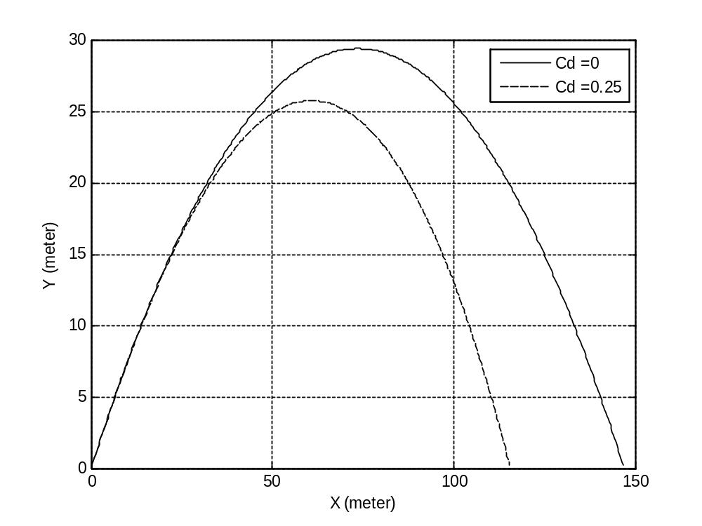
% a projectile motion Problem
% A ball of mass (m)= 0.200Kg , with cross section area (A) =3.5*10³ m²
% Moving with initial velocity (Vx)=30.0 m/s ,and (Vy)= 24.0 m/s
% and initial position (X)= 0.0 meter and, (Vy)= 0.0 meter
% with air resistance (p)= 1.2 Kg/m³
% and drag coefficient (Cd)= 0 or 0.25
% Earth Gravity (g)= 9.8 m/s^2
% Solving this problem using Adams-Bashforth (two-step)method

clear all;
clc;
% Initialization of Variabels
g=9.8;
p=1.2;
m=0.2;
h=0.01;
N=30/h;
A=3.5e-3;

Cd0=0;
Vx0(1)=30;
Vy0(1)=24;
ax0(1)=-0.5*p*Cd0*A*sqrt((Vx0(1)^2+Vy0(1)^2))*Vx0(1)/m;
ay0(1)=-0.5*p*Cd0*A*sqrt((Vx0(1)^2+Vy0(1)^2))*Vy0(1)/m;
Vx0(2)=Vx0(1)+h*(3/2)*ax0(1);
Vy0(2)=Vy0(1)+h*(3/2)*ay0(1);
X0(1)=0;
Y0(1)=0;
X0(2)=X0(1)+Vx0(1)*h+0.5*ax0(1)*h^2;
Y0(2)=Y0(1)+Vy0(1)*h+0.5*ay0(1)*h^2;
tfinal0=0;
maximum_hight0=0;
Range0=0;

for t=2:1:N
ax0(t)=-0.5*p*Cd0*A*sqrt((Vx0(t)^2+Vy0(t)^2))*Vx0(t)/m;
ay0(t)=-0.5*p*Cd0*A*sqrt((Vx0(t)^2+Vy0(t)^2))*Vy0(t)/m-g;

Vx0(t+1)=Vx0(t)+h*(1.5*ax0(t)-0.5*ax0(t-1));
Vy0(t+1)=Vy0(t)+h*(1.5*ay0(t)-0.5*ay0(t-1));
X0(t+1)=X0(t)+Vx0(t)*h+0.5*ax0(t)*h^2;
Y0(t+1)=Y0(t)+Vy0(t)*h+0.5*ay0(t)*h^2;

if Y0(t+1)>0
tfinal0=t+1;
Range0=X0(t+1);
end
if Y0(t+1)>Y0(t)
maximum_hight0=Y0(t+1);
end
end

%Theoritical Result for Cd=0
flight_time_theoritic=2*Vy0(1)/(0.5*p*Cd0*A*sqrt((Vx0(1)^2+Vy0(1)^2))*Vy0(1)/m+g)
maximum_hight_theoritic=Vy0(1)^2/(2*(0.5*p*Cd0*A*sqrt((Vx0(1)^2+Vy0(1)^2))*Vy0(1)/m+g))
Range_theoritic=Vx0(1)*flight_time_theoritic+0.5*ax0(tfinal0)*flight_time_theoritic^2

%Calculated Result for Cd=0
flight_time_computizes=tfinal0*h
maximum_hight_computized=maximum_hight0*1
Range_computized=Range0

Cd=0.25;
Vx(1)=30;
Vy(1)=24;
ax(1)=-0.5*p*Cd*A*sqrt((Vx(1)^2+Vy(1)^2))*Vx(1)/m;
ay(1)=-0.5*p*Cd*A*sqrt((Vx(1)^2+Vy(1)^2))*Vy(1)/m;
Vx(2)=Vx(1)+h*(3/2)*ax(1);
Vy(2)=Vy(1)+h*(3/2)*ay(1);
X(1)=0;
Y(1)=0;
X(2)=X(1)+Vx(1)*h+0.5*ax(1)*h^2;
Y(2)=Y(1)+Vy(1)*h+0.5*ay(1)*h^2;
tfinal=0;
maximum_hight=0;
Range=0;

for t=2:1:N
ax(t)=-0.5*p*Cd*A*sqrt((Vx(t)^2+Vy(t)^2))*Vx(t)/m;
ay(t)=-0.5*p*Cd*A*sqrt((Vx(t)^2+Vy(t)^2))*Vy(t)/m-g;

Vx(t+1)=Vx(t)+h*(1.5*ax(t)-0.5*ax(t-1));
Vy(t+1)=Vy(t)+h*(1.5*ay(t)-0.5*ay(t-1));
X(t+1)=X(t)+Vx(t)*h+0.5*ax(t)*h^2;
Y(t+1)=Y(t)+Vy(t)*h+0.5*ay(t)*h^2;

if Y(t+1)>0
tfinal=t+1;
Range=X(t+1);
end
if Y(t+1)>Y(t)
maximum_hight=Y(t+1);
end
% Vx(t+1)=Vxh(t);
% Vy(t+1)=Vyh(t);
end

%Theoritical Result for Cd=0.25
flight_time_theoritic=2*Vy(1)/(0.5*p*Cd*A*sqrt((Vx(1)^2+Vy(1)^2))*Vy(1)/m+g)
maximum_hight_theoritic=Vy(1)^2/(2*(0.5*p*Cd*A*sqrt((Vx(1)^2+Vy(1)^2))*Vy(1)/m+g))
Range_theoritic=Vx(1)*flight_time_theoritic+0.5*ax(tfinal)*flight_time_theoritic^2

%Calculated Result for Cd=0.25
flight_time_computized=tfinal*h
maximum_hight_computized=maximum_hight*1
Range_computized=Range

plot(X0(1:tfinal0),Y0(1:tfinal0),'black'), hold on;
plot(X(1:tfinal),Y(1:tfinal),'black--');
grid;
legend('Cd =0', 'Cd =0.25');
xlabel('X (meter)')
ylabel('Y (meter)')

Result of Solve by Adams-Bashforth (two-step)method

 | Cd=0 |  | Cd=0.25
 | theoritical | computized | theoritical | computized
flight_time | 4.8980 | 4.9100 | 3.9279 | 4.5900
maximum_hight | 29.3878 | 29.5083 | 23.5672 | 25.8025
Range | 146.9388 | 147.0000 | 104.8255 | 115.5151

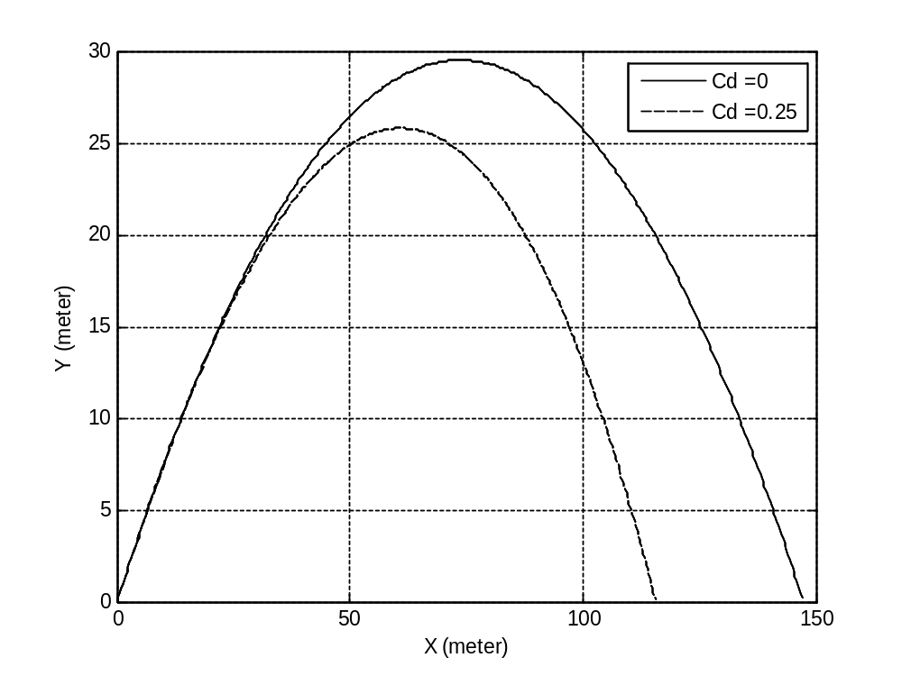

% a projectile motion Problem
% A ball of mass (m)= 0.200Kg , with cross section area (A) =3.5*10³ m²
% Moving with initial velocity (Vx)=30.0 m/s ,and (Vy)= 24.0 m/s
% and initial position (X)= 0.0 meter and, (Vy)= 0.0 meter
% with air resistance (p)= 1.2 Kg/m³
% and drag coefficient (Cd)= 0 or 0.25
% Earth Gravity (g)= 9.8 m/s^2
% Solving this problem using Adams-Bashforth (four-step)method

clear all;
clc;
% Initialization of Variabels
g=9.8;
p=1.2;
m=0.2;
h=0.01;
N=50/h;
A=3.5e-3;

Cd0=0;
Vx0(1)=30;
Vy0(1)=24;
ax0(1)=-0.5*p*Cd0*A*sqrt((Vx0(1)^2+Vy0(1)^2))*Vx0(1)/m;
ay0(1)=-0.5*p*Cd0*A*sqrt((Vx0(1)^2+Vy0(1)^2))*Vy0(1)/m-g;
Vx0(2)=Vx0(1)+h*(3/2)*ax0(1);
Vy0(2)=Vy0(1)+h*(3/2)*ay0(1);

ax0(2)=-0.5*p*Cd0*A*sqrt((Vx0(2)^2+Vy0(2)^2))*Vx0(2)/m;
ay0(2)=-0.5*p*Cd0*A*sqrt((Vx0(2)^2+Vy0(2)^2))*Vy0(2)/m-g;
Vx0(3)=Vx0(2)+h*(3/2)*ax0(2);
Vy0(3)=Vy0(2)+h*(3/2)*ay0(2);

ax0(3)=-0.5*p*Cd0*A*sqrt((Vx0(3)^2+Vy0(3)^2))*Vx0(3)/m;
ay0(3)=-0.5*p*Cd0*A*sqrt((Vx0(3)^2+Vy0(3)^2))*Vy0(3)/m-g;
Vx0(4)=Vx0(3)+h*(3/2)*ax0(3);
Vy0(4)=Vy0(3)+h*(3/2)*ay0(3);

ax0(4)=-0.5*p*Cd0*A*sqrt((Vx0(4)^2+Vy0(4)^2))*Vx0(4)/m;
ay0(4)=-0.5*p*Cd0*A*sqrt((Vx0(4)^2+Vy0(4)^2))*Vy0(4)/m-g;

X0(1)=0;
Y0(1)=0;
X0(2)=X0(1)+Vx0(1)*h+0.5*ax0(1)*h^2;
Y0(2)=Y0(1)+Vy0(1)*h+0.5*ay0(1)*h^2;
X0(3)=X0(2)+Vx0(2)*h+0.5*ax0(2)*h^2;
Y0(3)=Y0(2)+Vy0(2)*h+0.5*ay0(2)*h^2;
X0(4)=X0(3)+Vx0(3)*h+0.5*ax0(3)*h^2;
Y0(4)=Y0(3)+Vy0(3)*h+0.5*ay0(3)*h^2;
tfinal0=0;
maximum_hight0=0;
Range0=0;

for t=4:1:N
ax0(t)=-0.5*p*Cd0*A*sqrt((Vx0(t)^2+Vy0(t)^2))*Vx0(t)/m;
ay0(t)=-0.5*p*Cd0*A*sqrt((Vx0(t)^2+Vy0(t)^2))*Vy0(t)/m-g;
Vx0(t+1)=Vx0(t)+(h/24)*(55*ax0(t)-59*ax0(t-1)+37*ax0(t-2)-9*ax0(t-3));
Vy0(t+1)=Vy0(t)+(h/24)*(55*ay0(t)-59*ay0(t-1)+37*ay0(t-2)-9*ay0(t-3));
X0(t+1)=X0(t)+Vx0(t)*h+0.5*ax0(t)*h^2;
Y0(t+1)=Y0(t)+Vy0(t)*h+0.5*ay0(t)*h^2;

if Y0(t+1)>0
tfinal0=t+1;
Range0=X0(t+1);
end
if Y0(t+1)>Y0(t)
maximum_hight0=Y0(t+1);
end
end

%Theoritical Result for Cd=0
flight_time_theoritic=2*Vy0(1)/(0.5*p*Cd0*A*sqrt((Vx0(1)^2+Vy0(1)^2))*Vy0(1)/m+g)
maximum_hight_theoritic=Vy0(1)^2/(2*(0.5*p*Cd0*A*sqrt((Vx0(1)^2+Vy0(1)^2))*Vy0(1)/m+g))
Range_theoritic=Vx0(1)*flight_time_theoritic+0.5*ax0(tfinal0)*flight_time_theoritic^2

%Calculated Result for Cd=0
flight_time_computizes=tfinal0*h
maximum_hight_computized=maximum_hight0*1
Range_computized=Range0

Cd=0.25
Vx(1)=30;
Vy(1)=24;
ax(1)=-0.5*p*Cd*A*sqrt((Vx(1)^2+Vy(1)^2))*Vx(1)/m;
ay(1)=-0.5*p*Cd*A*sqrt((Vx(1)^2+Vy(1)^2))*Vy(1)/m-g;
Vx(2)=Vx(1)+h*(3/2)*ax(1);
Vy(2)=Vy(1)+h*(3/2)*ay(1);

ax(2)=-0.5*p*Cd*A*sqrt((Vx(2)^2+Vy(2)^2))*Vx(2)/m;
ay(2)=-0.5*p*Cd*A*sqrt((Vx(2)^2+Vy(2)^2))*Vy(2)/m-g;
Vx(3)=Vx(2)+h*(3/2)*ax(2);
Vy(3)=Vy(2)+h*(3/2)*ay(2);

ax(3)=-0.5*p*Cd*A*sqrt((Vx(3)^2+Vy(3)^2))*Vx(3)/m;
ay(3)=-0.5*p*Cd*A*sqrt((Vx(3)^2+Vy(3)^2))*Vy(3)/m-g;
Vx(4)=Vx(3)+h*(3/2)*ax(3);
Vy(4)=Vy(3)+h*(3/2)*ay(3);

ax(4)=-0.5*p*Cd*A*sqrt((Vx(4)^2+Vy(4)^2))*Vx(4)/m;
ay(4)=-0.5*p*Cd*A*sqrt((Vx(4)^2+Vy(4)^2))*Vy(4)/m-g;

X(1)=0;
Y(1)=0;
X(2)=X(1)+Vx(1)*h+0.5*ax(1)*h^2;
Y(2)=Y(1)+Vy(1)*h+0.5*ay(1)*h^2;
X(3)=X(2)+Vx(2)*h+0.5*ax(2)*h^2;
Y(3)=Y(2)+Vy(2)*h+0.5*ay(2)*h^2;
X(4)=X(3)+Vx(3)*h+0.5*ax(3)*h^2;
Y(4)=Y(3)+Vy(3)*h+0.5*ay(3)*h^2;
tfinal=0;
maximum_hight=0;
Range=0;

for t=4:1:N
ax(t)=-0.5*p*Cd*A*sqrt((Vx(t)^2+Vy(t)^2))*Vx(t)/m;
ay(t)=-0.5*p*Cd*A*sqrt((Vx(t)^2+Vy(t)^2))*Vy(t)/m-g;
Vx(t+1)=Vx(t)+(h/24)*(55*ax(t)-59*ax(t-1)+37*ax(t-2)-9*ax(t-3));
Vy(t+1)=Vy(t)+(h/24)*(55*ay(t)-59*ay(t-1)+37*ay(t-2)-9*ay(t-3));
X(t+1)=X(t)+Vx(t)*h+0.5*ax(t)*h^2;
Y(t+1)=Y(t)+Vy(t)*h+0.5*ay(t)*h^2;

if Y(t+1)>0
tfinal=t+1;
Range=X(t+1);
end
if Y(t+1)>Y(t)
maximum_hight=Y(t+1);
end
end

%Theoritical Result for Cd=0.25
flight_time_theoritic=2*Vy(1)/(0.5*p*Cd*A*sqrt((Vx(1)^2+Vy(1)^2))*Vy(1)/m+g)
maximum_hight_theoritic=Vy(1)^2/(2*(0.5*p*Cd*A*sqrt((Vx(1)^2+Vy(1)^2))*Vy(1)/m+g))
Range_theoritic=Vx(1)*flight_time_theoritic+0.5*ax(tfinal)*flight_time_theoritic^2

%Calculated Result for Cd=0.25
flight_time_computized=tfinal*h
maximum_hight_computized=maximum_hight*1
Range_computized=Range

plot(X0(1:tfinal0),Y0(1:tfinal0),'black'), hold on;
plot(X(1:tfinal),Y(1:tfinal),'black--');
grid;
legend('Cd =0', 'Cd =0.25');
xlabel('X (meter)')
ylabel('Y (meter)')
Result of Solve by Adams-Bashforth (four-step)method

 | Cd=0 |  | Cd=0.25
 | theoritical | computized | theoritical | computized
flight_time | 4.8980 | 4.8700 | 3.9279 | 4.5500
maximum_hight | 29.3878 | 29.0317 | 23.5672 | 25.3717
Range | 146.9388 | 145.8000 | 104.8339 | 114.5864

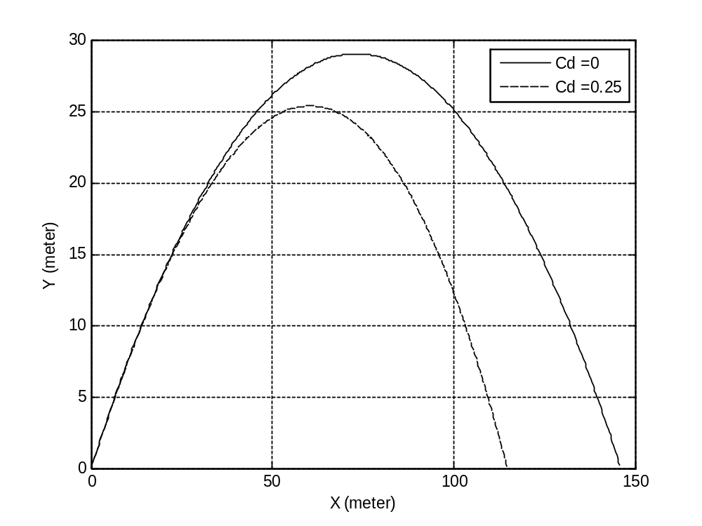

% a projectile motion Problem
% A ball of mass (m)= 0.200Kg , with cross section area (A) =3.5*10³ m²
% Moving with initial velocity (Vx)=30.0 m/s ,and (Vy)= 24.0 m/s
% and initial position (X)= 0.0 meter and, (Vy)= 0.0 meter
% with air resistance (p)= 1.2 Kg/m³
% and drag coefficient (Cd)= 0 or 0.25
% Earth Gravity (g)= 9.8 m/s^2
% Solving this problem using Adams-Moulton (quadratic polynomial)method
clear all;
clc;
% Initialization of Variabels
g=9.8;
p=1.2;
m=0.2;
h=0.01;
N=30/h;
A=3.5e-3;
Cd0=0;
Vx0(1)=30;
Vy0(1)=24;
ax0(1)=-0.5*p*Cd0*A*sqrt((Vx0(1)^2+Vy0(1)^2))*Vx0(1)/m;
ay0(1)=-0.5*p*Cd0*A*sqrt((Vx0(1)^2+Vy0(1)^2))*Vy0(1)/m;
Vx0(2)=Vx0(1)+(h/7)*8*ax0(1);
Vy0(2)=Vy0(1)+(h/7)*8*ay0(1);
X0(1)=0;
Y0(1)=0;
X0(2)=X0(1)+Vx0(1)*h+0.5*ax0(1)*h^2;
Y0(2)=Y0(1)+Vy0(1)*h+0.5*ay0(1)*h^2;
tfinal0=0;
maximum_hight0=0;
Range0=0;

for t=2:1:N
ax0(t)=-0.5*p*Cd0*A*sqrt((Vx0(t)^2+Vy0(t)^2))*Vx0(t)/m;
ay0(t)=-0.5*p*Cd0*A*sqrt((Vx0(t)^2+Vy0(t)^2))*Vy0(t)/m-g;
Vx0(t+1)=Vx0(t)+(h/7)*(8*ax0(t)-ax0(t-1));
Vy0(t+1)=Vy0(t)+(h/7)*(8*ay0(t)-ay0(t-1));
X0(t+1)=X0(t)+Vx0(t)*h+0.5*ax0(t)*h^2;
Y0(t+1)=Y0(t)+Vy0(t)*h+0.5*ay0(t)*h^2;

if Y0(t+1)>0
tfinal0=t+1;
Range0=X0(t+1);
end
if Y0(t+1)>Y0(t)
maximum_hight0=Y0(t+1);
end
end
%Theoritical Result for Cd=0
flight_time_theoritic=2*Vy0(1)/(0.5*p*Cd0*A*sqrt((Vx0(1)^2+Vy0(1)^2))*Vy0(1)/m+g)
maximum_hight_theoritic=Vy0(1)^2/(2*(0.5*p*Cd0*A*sqrt((Vx0(1)^2+Vy0(1)^2))*Vy0(1)/m+g))
Range_theoritic=Vx0(1)*flight_time_theoritic+0.5*ax0(tfinal0)*flight_time_theoritic^2
%Calculated Result for Cd=0
flight_time_computizes=tfinal0*h
maximum_hight_computized=maximum_hight0*1
Range_computized=Range0
Cd=0.25
Vx(1)=30;
Vy(1)=24;
ax(1)=-0.5*p*Cd*A*sqrt((Vx(1)^2+Vy(1)^2))*Vx(1)/m;
ay(1)=-0.5*p*Cd*A*sqrt((Vx(1)^2+Vy(1)^2))*Vy(1)/m;
Vx(2)=Vx(1)+(h/7)*8*ax(1);
Vy(2)=Vy(1)+(h/7)*8*ay(1);
X(1)=0;
Y(1)=0;
X(2)=X(1)+Vx(1)*h+0.5*ax(1)*h^2;
Y(2)=Y(1)+Vy(1)*h+0.5*ay(1)*h^2;
tfinal=0;
maximum_hight=0;
Range=0;
for t=2:1:N
ax(t)=-0.5*p*Cd*A*sqrt((Vx(t)^2+Vy(t)^2))*Vx(t)/m;
ay(t)=-0.5*p*Cd*A*sqrt((Vx(t)^2+Vy(t)^2))*Vy(t)/m-g;
Vx(t+1)=Vx(t)+(h/7)*(8*ax(t)-ax(t-1));
Vy(t+1)=Vy(t)+(h/7)*(8*ay(t)-ay(t-1));
X(t+1)=X(t)+Vx(t)*h+0.5*ax(t)*h^2;
Y(t+1)=Y(t)+Vy(t)*h+0.5*ay(t)*h^2;
if Y(t+1)>0
tfinal=t+1;
Range=X(t+1);
end
if Y(t+1)>Y(t)
maximum_hight=Y(t+1);
end
% Vx(t+1)=Vxh(t);
% Vy(t+1)=Vyh(t);
end
%Theoritical Result for Cd=0.25
flight_time_theoritic=2*Vy(1)/(0.5*p*Cd*A*sqrt((Vx(1)^2+Vy(1)^2))*Vy(1)/m+g)
maximum_hight_theoritic=Vy(1)^2/(2*(0.5*p*Cd*A*sqrt((Vx(1)^2+Vy(1)^2))*Vy(1)/m+g))
Range_theoritic=Vx(1)*flight_time_theoritic+0.5*ax(tfinal)*flight_time_theoritic^2
%Calculated Result for Cd=0.25
flight_time_computized=tfinal*h
maximum_hight_computized=maximum_hight*1
Range_computized=Range

plot(X0(1:tfinal0),Y0(1:tfinal0),'black'), hold on;
plot(X(1:tfinal),Y(1:tfinal),'black--');
grid;
legend('Cd =0', 'Cd =0.25');
xlabel('X (meter)')
ylabel('Y (meter)')

Result of Solve by Adams-Moulton(quadratic polynomial )

 | Cd=0 |  | Cd=0.25
 | theoritical | computized | theoritical | computized
flight_time | 4.8980 | 4.9200 | 3.9279 | 4.6000
maximum_hight | 29.3878 | 29.5936 | 23.5672 | 25.8775
Range | 146.9388 | 147.3000 | 104.8189 | 115.7450

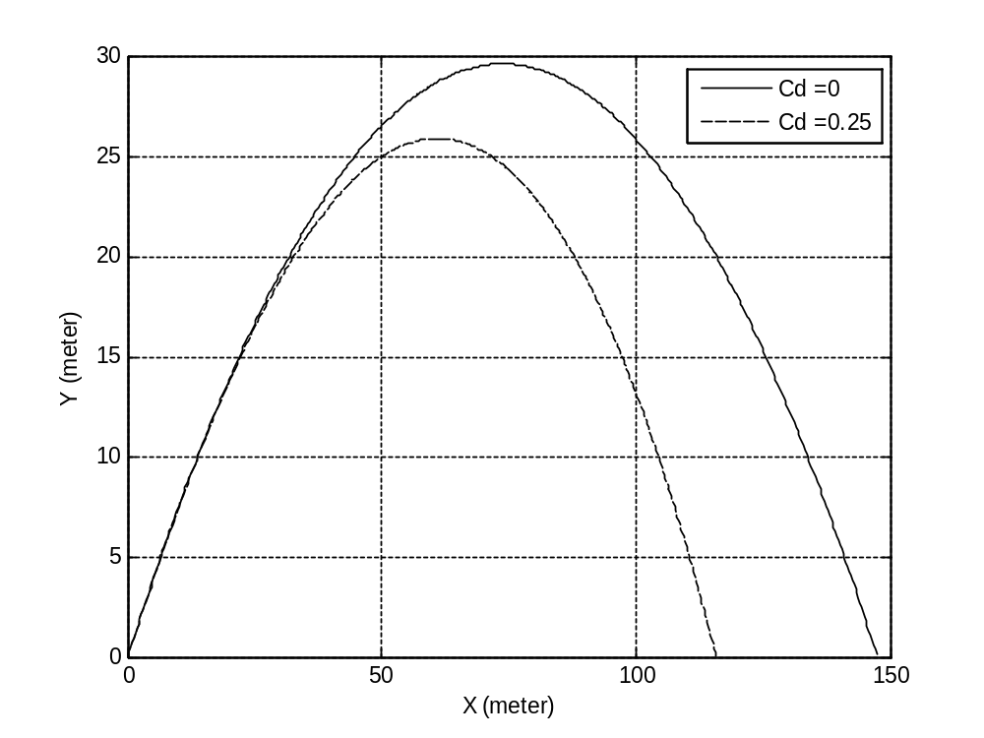

% a projectile motion Problem
% A ball of mass (m)= 0.200Kg , with cross section area (A) =3.5*10³ m²
% Moving with initial velocity (Vx)=30.0 m/s ,and (Vy)= 24.0 m/s
% and initial position (X)= 0.0 meter and, (Vy)= 0.0 meter
% with air resistance (p)= 1.2 Kg/m³
% and drag coefficient (Cd)= 0 or 0.25
% Earth Gravity (g)= 9.8 m/s^2
% Solving this problem using Adams-Moulton(cupic)method

clear all;
clc;
% Initialization of Variabels
g=9.8;
p=1.2;
m=0.2;
h=0.01;
N=50/h;
A=3.5e-3;

Cd0=0;
Vx0(1)=30;
Vy0(1)=24;
ax0(1)=-0.5*p*Cd0*A*sqrt((Vx0(1)^2+Vy0(1)^2))*Vx0(1)/m;
ay0(1)=-0.5*p*Cd0*A*sqrt((Vx0(1)^2+Vy0(1)^2))*Vy0(1)/m-g;
Vx0(2)=Vx0(1)+(h/24)*(55*ax0(1));
Vy0(2)=Vy0(1)+(h/24)*(55*ay0(1));
ax0(2)=-0.5*p*Cd0*A*sqrt((Vx0(2)^2+Vy0(2)^2))*Vx0(2)/m;
ay0(2)=-0.5*p*Cd0*A*sqrt((Vx0(2)^2+Vy0(2)^2))*Vy0(2)/m-g;
Vx0(3)=Vx0(2)+(h/24)*(55*ax0(2)-59*ax0(1));
Vy0(3)=Vy0(2)+(h/24)*(55*ay0(2)-59*ay0(1));
ax0(3)=-0.5*p*Cd0*A*sqrt((Vx0(3)^2+Vy0(3)^2))*Vx0(3)/m;
ay0(3)=-0.5*p*Cd0*A*sqrt((Vx0(3)^2+Vy0(3)^2))*Vy0(3)/m-g;
Vx0(4)=Vx0(3)+(h/24)*(55*ax0(3)-59*ax0(2)+37*ax0(1));
Vy0(4)=Vy0(3)+(h/24)*(55*ay0(3)-59*ay0(2)+37*ay0(1));
ax0(4)=-0.5*p*Cd0*A*sqrt((Vx0(4)^2+Vy0(4)^2))*Vx0(4)/m;
ay0(4)=-0.5*p*Cd0*A*sqrt((Vx0(4)^2+Vy0(4)^2))*Vy0(4)/m-g;
Vx0(5)=Vx0(4)+(h/24)*(55*ax0(4)-59*ax0(3)+37*ax0(2)-9*ax0(1));
Vy0(5)=Vy0(4)+(h/24)*(55*ay0(4)-59*ay0(3)+37*ay0(2)-9*ay0(1));
X0(1)=0;
Y0(1)=0;
X0(2)=X0(1)+Vx0(1)*h+0.5*ax0(1)*h^2;
Y0(2)=Y0(1)+Vy0(1)*h+0.5*ay0(1)*h^2;
X0(3)=X0(2)+Vx0(2)*h+0.5*ax0(2)*h^2;
Y0(3)=Y0(2)+Vy0(2)*h+0.5*ay0(2)*h^2;
X0(4)=X0(3)+Vx0(3)*h+0.5*ax0(3)*h^2;
Y0(4)=Y0(3)+Vy0(3)*h+0.5*ay0(3)*h^2;
tfinal0=0;
maximum_hight0=0;
Range0=0;

for t=4:1:N
ax0(t)=-0.5*p*Cd0*A*sqrt((Vx0(t)^2+Vy0(t)^2))*Vx0(t)/m;
ay0(t)=-0.5*p*Cd0*A*sqrt((Vx0(t)^2+Vy0(t)^2))*Vy0(t)/m-g;
Vx0(t+1)=Vx0(t)+(h/24)*(55*ax0(t)-59*ax0(t-1)+37*ax0(t-2)-9*ax0(t-3));
Vy0(t+1)=Vy0(t)+(h/24)*(55*ay0(t)-59*ay0(t-1)+37*ay0(t-2)-9*ay0(t-3));
X0(t+1)=X0(t)+Vx0(t)*h+0.5*ax0(t)*h^2;
Y0(t+1)=Y0(t)+Vy0(t)*h+0.5*ay0(t)*h^2;
if Y0(t+1)>0
tfinal0=t+1;
Range0=X0(t+1);
end
if Y0(t+1)>Y0(t)
maximum_hight0=Y0(t+1);
end
end
%Theoritical Result for Cd=0
flight_time_theoritic=2*Vy0(1)/(0.5*p*Cd0*A*sqrt((Vx0(1)^2+Vy0(1)^2))*Vy0(1)/m+g)
maximum_hight_theoritic=Vy0(1)^2/(2*(0.5*p*Cd0*A*sqrt((Vx0(1)^2+Vy0(1)^2))*Vy0(1)/m+g))
Range_theoritic=Vx0(1)*flight_time_theoritic+0.5*ax0(tfinal0)*flight_time_theoritic^2
%Calculated Result for Cd=0
flight_time_computizes=tfinal0*h
maximum_hight_computized=maximum_hight0*1
Range_computized=Range0

Cd=0.25
Vx(1)=30;
Vy(1)=24;
ax(1)=-0.5*p*Cd*A*sqrt((Vx(1)^2+Vy(1)^2))*Vx(1)/m;
ay(1)=-0.5*p*Cd*A*sqrt((Vx(1)^2+Vy(1)^2))*Vy(1)/m-g;
Vx(2)=Vx(1)+(h/24)*(55*ax(1));
Vy(2)=Vy(1)+(h/24)*(55*ay(1));
ax(2)=-0.5*p*Cd*A*sqrt((Vx(2)^2+Vy(2)^2))*Vx(2)/m;
ay(2)=-0.5*p*Cd*A*sqrt((Vx(2)^2+Vy(2)^2))*Vy(2)/m-g;
Vx(3)=Vx(2)+(h/24)*(55*ax(2)-59*ax(1));
Vy(3)=Vy(2)+(h/24)*(55*ay(2)-59*ay(1));
ax(3)=-0.5*p*Cd*A*sqrt((Vx(3)^2+Vy(3)^2))*Vx(3)/m;
ay(3)=-0.5*p*Cd*A*sqrt((Vx(3)^2+Vy(3)^2))*Vy(3)/m-g;
Vx(4)=Vx(3)+(h/24)*(55*ax(3)-59*ax(2)+37*ax(1));
Vy(4)=Vy(3)+(h/24)*(55*ay(3)-59*ay(2)+37*ay(1));
ax(4)=-0.5*p*Cd*A*sqrt((Vx(4)^2+Vy(4)^2))*Vx(4)/m;
ay(4)=-0.5*p*Cd*A*sqrt((Vx(4)^2+Vy(4)^2))*Vy(4)/m-g;
Vx(5)=Vx(4)+(h/24)*(55*ax(4)-59*ax(3)+37*ax(2)-9*ax(1));
Vy(5)=Vy(4)+(h/24)*(55*ay(4)-59*ay(3)+37*ay(2)-9*ay(1));
X(1)=0;
Y(1)=0;
X(2)=X(1)+Vx(1)*h+0.5*ax(1)*h^2;
Y(2)=Y(1)+Vy(1)*h+0.5*ay(1)*h^2;
X(3)=X(2)+Vx(2)*h+0.5*ax(2)*h^2;
Y(3)=Y(2)+Vy(2)*h+0.5*ay(2)*h^2;
X(4)=X(3)+Vx(3)*h+0.5*ax(3)*h^2;
Y(4)=Y(3)+Vy(3)*h+0.5*ay(3)*h^2;
tfinal=0;
maximum_hight=0;
Range=0;

for t=4:1:N
ax(t)=-0.5*p*Cd*A*sqrt((Vx(t)^2+Vy(t)^2))*Vx(t)/m;
ay(t)=-0.5*p*Cd*A*sqrt((Vx(t)^2+Vy(t)^2))*Vy(t)/m-g;
Vx(t+1)=Vx(t)+(h/24)*(55*ax(t)-59*ax(t-1)+37*ax(t-2)-9*ax(t-3));
Vy(t+1)=Vy(t)+(h/24)*(55*ay(t)-59*ay(t-1)+37*ay(t-2)-9*ay(t-3));
X(t+1)=X(t)+Vx(t)*h+0.5*ax(t)*h^2;
Y(t+1)=Y(t)+Vy(t)*h+0.5*ay(t)*h^2;
if Y(t+1)>0
tfinal=t+1;
Range=X(t+1);
end
if Y(t+1)>Y(t)
maximum_hight=Y(t+1);
end
end
%Theoritical Result for Cd=0.25
flight_time_theoritic=2*Vy(1)/(0.5*p*Cd*A*sqrt((Vx(1)^2+Vy(1)^2))*Vy(1)/m+g)
maximum_hight_theoritic=Vy(1)^2/(2*(0.5*p*Cd*A*sqrt((Vx(1)^2+Vy(1)^2))*Vy(1)/m+g))
Range_theoritic=Vx(1)*flight_time_theoritic+0.5*ax(tfinal)*flight_time_theoritic^2
%Calculated Result for Cd=0.25
flight_time_computized=tfinal*h
maximum_hight_computized=maximum_hight*1
Range_computized=Range

plot(X0(1:tfinal0),Y0(1:tfinal0),'black'), hold on;
plot(X(1:tfinal),Y(1:tfinal),'black--');
grid;
legend('Cd =0', 'Cd =0.25');
xlabel('X (meter)')
ylabel('Y (meter)')

Result of Solve by Adams-Moulton(cupic polynomial )

 | Cd=0 |  | Cd=0.25
 | theoritical | computized | theoritical | computized
flight_time | 4.8980 | 4.8900 | 3.9279 | 4.5700
maximum_hight | 29.3878 | 29.2679 | 23.5672 | 25.6081
Range | 146.9388 | 146.4000 | 104.8245 | 115.1003

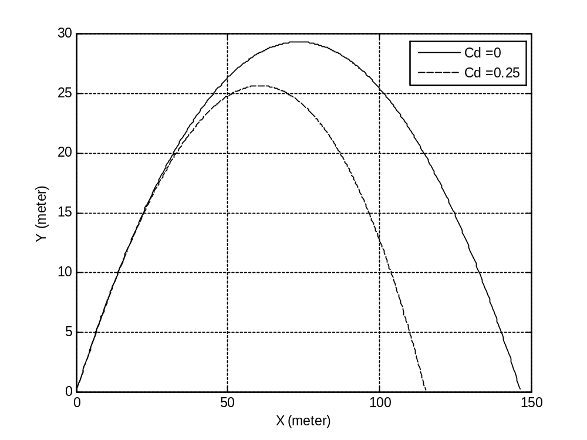
Comparison among all methods:

Cd=0 | Theoretical  value | Simple (Euler) | Taylor | Adams-Bash-forth 2-step | Adams-Bash-forth 4-step | Adams-Moulton  (quadr) | Adams Moulton  (cupic)
flight_tim | 4.8980 | 4.9000 | 4.9000 | 4.9100 | 4.8700 | 4.9200 | 4.8900
Max_hight | 29.3878 | 29.3878 | 29.388 | 29.508 | 29.031 | 29.5936 | 29.2679
Range | 146.938 | 146.700 | 146.69 | 147.00 | 145.80 | 147.300 | 146.400

By comparing with theoretical result , the best computized result is :
(Simple method ) for Cd=0.

Cd=0.25 | Theoret  ical  value | Simple (Euler) | Taylor | Adams-Bash-forth 2-step | Adams-Bash-forth 4-step | Adams-Moulton  (quadr) | Adams Moulton  (cupic)
flight_tim | 3.9279 | 4.5800 | 4.5800 | 4.5900 | 4.5500 | 4.6000 | 4.5700
Max_hight | 23.5672 | 25.7132 | 25.7426 | 25.8025 | 25.3717 | 25.8775 | 25.6081
Range | 104.8245 | 115.337 | 115.382 | 115.515 | 114.586 | 115.7450 | 115.1003

By comparing with theoretical result , the best computized result is:
(Adams-Bash-forth 4-step) for Cd=0.25.

